**Date:17/3/2025**

## EXPERIMENT-18

## CONFIGURATION OF FIREWALL IN PACKET TRACER

**Aim:** To configure firewall in packet tracer.

**Software/Apparatus required:** Packet Tracer/End devices, Hubs, connectors.

**Procedure:**

Step 1: Set up the network topology

To begin, we will create a simple network topology consisting of three computers, a router, and a firewall. Open Packet Tracer and drag three PCs, a router, and a firewall onto the workspace. Connect the three PCs to the router using Ethernet cables, and connect the firewall to the router using another Ethernet cable.

Step 2: Configure IP addresses

Next, we will configure IP addresses for the computers. Double-click on each PC to open the configuration window and navigate to the Desktop tab. Click on the IP Configuration icon and enter the IP address and subnet mask for each computer. For example, PC1 can have an IP address of 192.168.1.1 with a subnet mask of 255.255.255.0, PC2 can have an IP address of 192.168.1.2 with the same subnet mask, and PC3 can have an IP address of 192.168.1.3 with the same subnet mask

Step 3: Configure the router

Now, we will configure the router. Double-click on the router to open the configuration window and navigate to the CLI tab. Enter the following commands:

**Commands :**

enable configure terminal interface FastEthernet0/0

ip address 192.168.1.254 255.255.255.0 no shutdown

exit

Step 4: Configure the firewall

Now, we will configure the firewall. Double-click on the firewall to open the configuration window

Step 5: Test the connection

Now that the firewall is configured, we can test the connection between the computers. Open a command prompt on PC1 and ping PC2 and PC3 by typing ping 192.168.1.2 and ping 192.168.1.3 in the command prompt. If the pings are successful, it means that the computers are communicating with each other.

Step 6: Test the firewall

To test the firewall, try to connect to PC1 from the internet using a protocol or port that is not allowed by the access rule. For example, you can try to connect to PC1 using Telnet on port 23. DIAGRAM

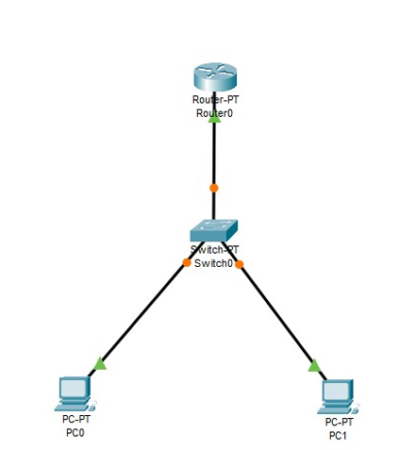

OUTPUT

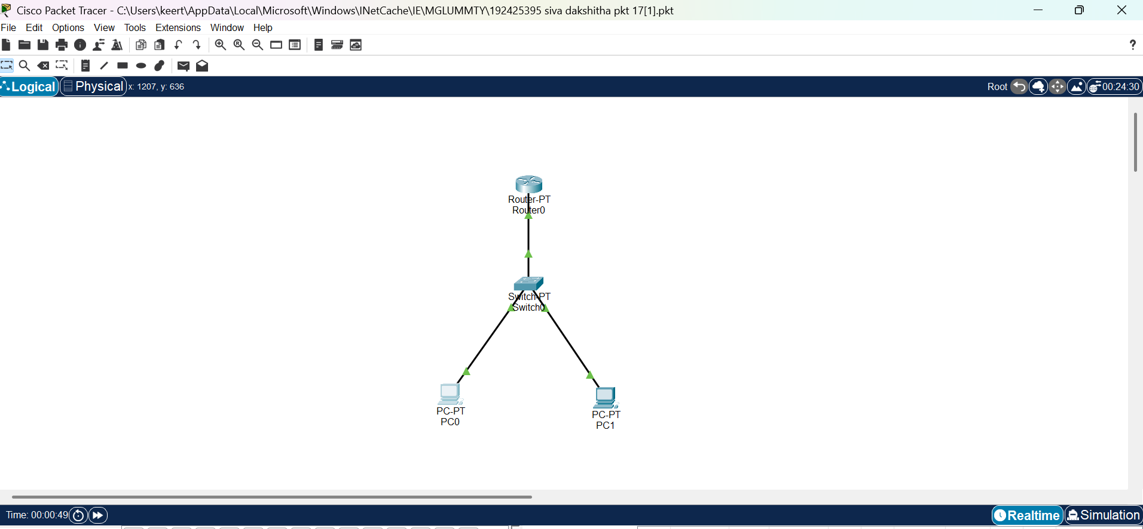

**Result:** Hencethe configuration of firewall in packet tracer is successful.